List of the Belarusian participants
online B2B - 22 September, 2020
Argentina

15.09.2020
№ |  | Organization / Name | Info
1. |  | Minsk Tractor Works  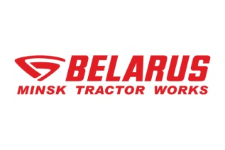  1.Mr  220070, República de Belarús, Minsk st. Dolgobrodskaya 29  +375 17 246-60-09 (servicio de información, hora de Minsk, +3 GMT)  Fax: +375 17 398-89-50  sales@belarus-tractor.com  www. http://www.belarus-tractor.com/es/  Katalog  http://www.belarus-tractor.com/es/catalog/product-catalogs/ | Business profile/Activity:  Minsk Tractor Works is one of the world largest manufacturers of agricultural machinery.  Minsk Tractor Works history starts in 1946 when the factory was formed. During its history MTW became a managing company of MTW-HOLDING with 9 factories in the Republic of Belarus with more than 22 700 employees, 28 assembly plants in 16 countries around the world and presence in more than 60 countries.  Today Holding production capacity reached 75 000 pcs. per year, our model range starts from 9 h.p. walking tractor till 350 h.p. universal tractor, our tractors have been supplied to more than 125 countries around the globe and reached a honored reputation of heavy duty machinery.  Tractors “Belarus” are certified according to international quality standards. Competitiveness of the products of MTW is tested by a long term representation in the markets of developed countries with different climatic conditions.  Farmers all over the world are attracted by the tractors "Belarus” primarily because of their service reliability, ease of operation, availability of maintenance and reasonable prices.  Offered products  - Los tractores están diseñados para diversas operaciones agrícolas con uso general que llevan las maquinas remolcadas y herramientas y accesorios montados y semi-montados.  - Los tractores especiales están diseñados para la mecanización de las operaciones agrícolas especiales y llevan las maquinas remolcadas y herramientas y accesorios montados y semi-montados.  - La maquinaria especializada se utiliza para la elaboración y recolección de la cosecha, su carga y para diversos trabajos de movimiento de tierra.  - Las máquinas forestales están diseñadas para realizar diversas tareas en reforestación y mantenimiento de los bosques.  - Los accesorios para acoplar están diseñados para diversas operaciones agrícolas como parte de las unidades de máquinas y tractores.  - Los artículos para el hogar sirven para diversas necesidades de la población.  Potentials partners:  MTW is interested in establishing contacts with:  • importers of agricultural machinery;  • big agricultural enterprises and holdings  interested in organizing long term cooperation and development of dealer network of “Belarus” tractors in Argentina  • representatives of the ministry of agriculture and other organizations engaged in organizing tenders for supply of tractors to Argentina;
2. |  | Republic of Belarus  12 Kalinin Lane, 220012, Minsk  +375 17 280 01 31  +375 17 280 98 78  +375 17 281 77 34  info@holography.by  www.holography.by/en | Business profile/Activity:  Holography Industry JSC specializes in holographic products manufacture used to mark and identify a wide range of goods, security papers and documents.  Close cooperation with International Hologram Manufacturers Association (IHMA) guarantees registration of an image, which excludes the possibility of unauthorized duplication of the holographic image ordered by you.  Our customers are the enterprises , who are interested in their product protection. The largest state organisatiobs, various commercial companies of East and West Europe such as perfume products, pharmaceutical, audio and video products manufactures. Goznak of Belarus, Russia, Kazakhstan and Lithuania are among our valuable clients.  Our main products:  Holographic stickers  If you care about your product security, the holographic sticker is exactly the source of making it effective and original at the same time providing the authenticity of your product.  Holographic foil  Hot stamping holographic foil is aimed at holographic image transfer to the product by means of polygraphic technique.  Holographic foil, as well as other holographic images applied to the package, is a sort of identification and at the same time decoration feature which attracts the customers’ attention. It’s really not the least of the factors for the producer in the present competitive environment.  Holographic laminating pouch for authentication passes.  It is also called a laminating pocket for authentication documents, an overlay or simply a laminating pocket for documents. In case of attempt to open-up a holographic layer will be destroyed, that leads to document visual changes and the document will be determined as it was attempted to be imitated.  Blister package with holographic security features  We offer a blister package with holographic security features. This product was initially produced for certified diamonds packaging.  Due to a transparent “window” the product is not hidden but can be seen almost to its full extent which allows the customer to scrutinize the product before purchasing it.  Function: to discover unauthorized access to the product after its enclosure into the package.  Our company interested in  partnership with companies of following spheres of activity: polygraphy (security printing); pharmacy; jewelry; cosmetics and perfumery; food industry.
3. | El Centro Cientifico у Tecnico "LEMT" del Holding "BelOMO" (en adelante - CCT "LEMT")  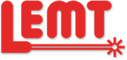  23/1, Makayonok Str., Minsk, 220114, Republic of Belarus  +375 17 373-92-00  office@lemt.by  https://en.lemt.by |  | CCT "LEMT" Scientific and Technical Center of the BelOMO was founded on June 02, 1992 as the result of structural reorganization of the Belarusian Optical and Mechanical Association, a flagship of instrumentation of the Republic of Belarus, and one of the biggest optic companies of the Eastern Europe. LEMT Scientific and Technical Center specializes in scientific research, development, production and upgrading of opto-electronic and laser devices of civil and military purpose.  El Centro Cientifico у Tecnico "LEMT" del Holding "BelOMO" (en adelante - CCT "LEMT") desea crear su propia red de asociados de negocios en America Latina y, en particular, en Argentina.  Lo que CCT "LEMT" quere:  - suministrar sistemas laser, nocturnos, de imagenes termicas у optoelectronicos para todo tipo de armas en la policia, las agencias fronterizas, as! сото las fuerzas de operaciones especiales de Argentina (lista de productos en www.lemt.by);  - organizar centros de servicio para la reparacion у mantenimiento de este tipo de productos;  - crear una planta de ensamblaje conjunta en el territorio de Argentina, incluso la transferencia de tecnologla de CCT "LEMT";  - invitar a representantes del Ministerio de Defensa у empresas industriales del complejo militar de Argentina a Minsk a nuestra empresa.  Para esto estamos listos:  - firmar un acuerdo para servicios intermediarios con empresas privaclas у pagar sus servicios;  - dar toda la informacion у materiales necesarios;  - organizar viajes de negocios a Argentina de nuestros especialistas para las negociaciones у presentacion de nuestros productos especiales.
4. | JV Santa Bremor LLC  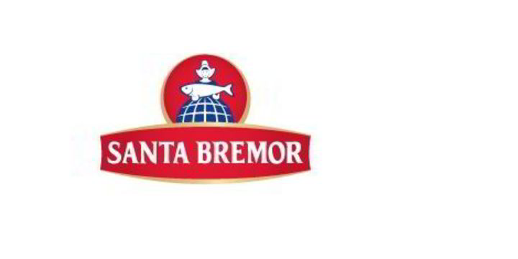  Republic of Belarus,  224025 Brest, Katin Bor str., 106;  Mazyrka.Svetlana@santa.by; export@santa.by.  +375 162 29 90 50  +375 44 570 32 03  www.santabremor.com  https://en.santabremor.com/?geopopup=en |  | Business profile/Activity:  Santa Bremor is a multi-category manufacturer. The company started its business in 1998 with herring processing. Today the production includes more than 1000 food items in 13 categories: herring, salmon, caviar, capelin caviar in sauce, spreads, seafood, surimi, canned fish, salads, seaweed, semi-finished products, ice cream, water and soft drinks. The company's products are sold in 37 countries.  The company employs over 4800 people.  Santa Bremor uses the best recipes and technological innovations, and also strictly controls the quality at all stages of production. The company has implemented and certified systems HACCP, ISO 9001, IFS Food, BRC.  Santa Bremor offers more than good quality products: we delight our customers with exquisite dishes and let them enjoy wonderful taste.  We are commited to transparancy and responsibility in business.  Offered products, services:  Presentaion of products is attached  Commercial offer - https://we.tl/t-IN0V9j0any  Interested in:  Company JV “Santa Bremor” LLC is interested in promotion of the company’s products to the Argentine market. We are interested in establishing long-term partnership relations with companies that have experience in working with food products, retail, refrigeration equipment, appropriate storage warehouses and transport.
5 | OJSC Kamvol  Republic of Belarus,  Minsk, st. Mayakovsky, 176  kamvol@bk.ru  kamvol@tut.by  Tel. +37517 397-14-18  https://www.kamvol.by |  | Business profile/Activity:  OJSC Kamvol is one of the largest producers of high-quality fabrics with wool content in the CIS and Europe.  Open joint stock company "Kamvol" is the largest manufacturer of textile products, with full production cycle from processing of wool, manufacturing yarn,  to the production of fabrics and supplying products to Europe and the Union of independent States.  Today, JSC Kamvol can offer you a wide range of modern dress-and-suit and trouser pure wool, wool, half-woolen fabrics with embedding of polyester fiber, viscose, PA, PAN, lycra and elastane yarn in various combinations.  Over its history, worsted fabric was supplied to consumers in more than 30 countries of near and far abroad. Currently, the geography of deliveries of products of the enterprise: Russia, Ukraine, Moldova, Armenia, Azerbaijan, Turkmenistan, Tajikistan, Kyrgyzstan, Uzbekistan, Kazakhstan, Turkey, Latvia, Serbia, Poland, Lithuania.  Interested in finding partners in Argentina.

6 | CJSC «MZBN» — Closed Joint-Stock Company «Minsk Soft Drink Factory»  19 Makaenak St., 220114 Minsk, Republic of Belarus  info@mzbn.com  www.mzbn.com | CJSC «MZBN» — Closed Joint-Stock Company «Minsk Soft Drink Factory» has supplied the Belarusian market with mineral and potable water as well as non-alcoholic beverages for fifty years already. The manufacture is based on own natural sources of mineral and potable water located in the territory of the plant.  At present the enterprise is the largest manufacturer in Belarus with a total capacity of more than 22 million litres a year, as well as is the only manufacturer in the Republic of Belarus, which possesses a hot pour technology. The technology allows manufacturing of products in PET bottles without adding preservatives.  At present the enterprise assortment includes 11 trade marks, among which well-known ones such as Minskaja-4, Bela-Cola, Rosinka, Fun-Fun, Multitel, Kvasych and others.  Total capacity of the equipment makes about 480 thousand bottles a day.  Interested in meetings with potential partners (representatives of distribution companies and retail chains) to present Birch tree water and other products and negotiate on possible cooperation and sales.

